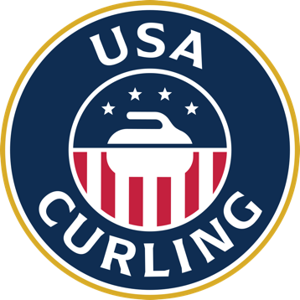 | UNITED STATES CURLING ASSOCIATION  Annual Members’ Meeting  October 13, 2023 - Bloomington, MN  In person and via teleconference  AGENDA

1 | Convene Members Meeting — Call to Order | Bret Jackson, Chair
2 | Appointment of Parliamentarian | Jackson  Todd Ellis, Parliamentarian
3 | Certification of votes | Alexis Boccanfuso, Treasurer  Roger Smith, Director
4 | Roll Call | Dick Dawson, Secretary
5 | Overview of Meeting process and background | Jackson
6 | Determination of Quorum | Dawson
9 | Approval of Minutes - 2022 Members’ Assembly | Dawson
10 | Approval of USA Curling Member Clubs (below) | Dawson
11 | Approval of incoming Directors (below) | Dawson
12 | Discussion of By-Laws Amendments | Jackson  Gemmell  Michael Shalhoub, Nomination & Governance
13 | Ratification Vote on By-Laws Amendments | Dawson
14 | Report by the Chair of Board of Directors | Jackson
15 | Report by the Chief Executive Officer | Dean Gemmell, CEO
16 | Adjourn | All

Addenda

Member Clubs with Provisional Status under consideration for full membership:

  - Fergus Falls Area Curling, Fergus Falls, Minnesota
  - Mower County Curling Club, Austin, MN
  - Northstar Curling Club, Sartell, Minnesota
  - Rhinelander Curling, Rhinelander WI
  - Talkeenta Curling, Talkeetna, AK

Nominations for Director to USA Curling Board

- Phil Shyrock, PNWCA/MOPAC/Alaska
- Brian Kopp, Wisconsin

